**Model Development Phase Template**

|  |  |
| --- | --- |
| Date | 08 July 2024 |
| Team ID | SWTID1720075414 |
| Project Title | Panic Disorder Detection |
| Maximum Marks | 4 Marks |

**Initial Model Training Code, Model Validation and Evaluation Report**

The initial model training code will be showcased in the future through a screenshot. The model validation and evaluation report will include classification reports, accuracy, and confusion matrices for multiple models, presented through respective screenshots.

**Initial Model Training Code:**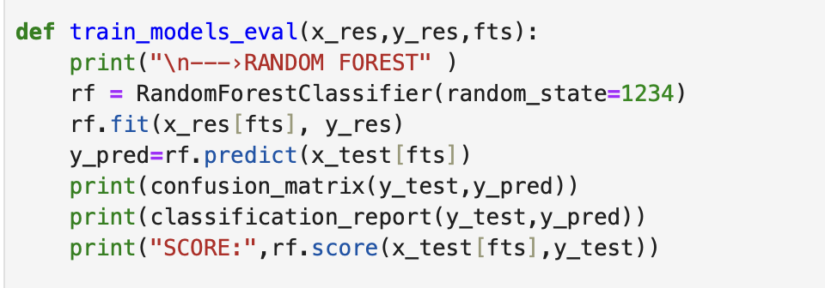

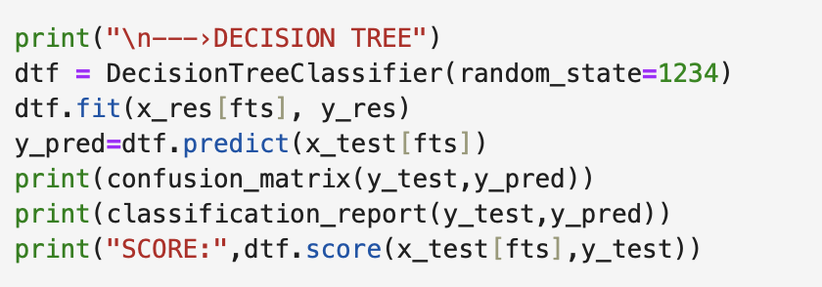

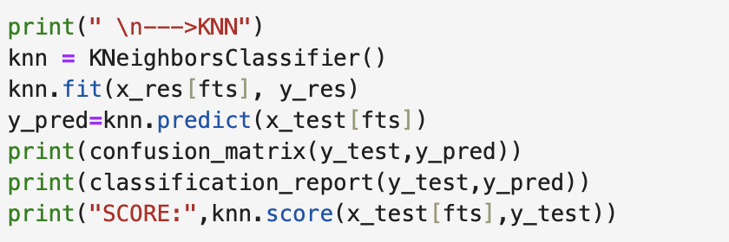

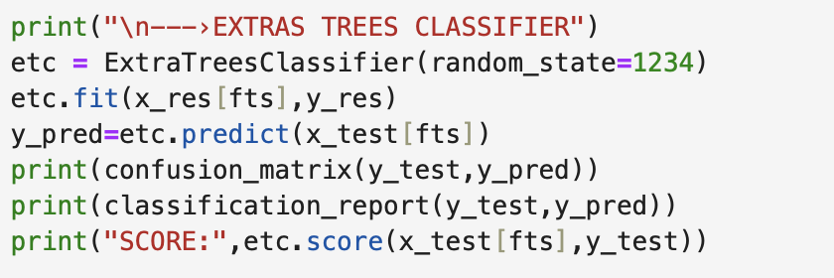

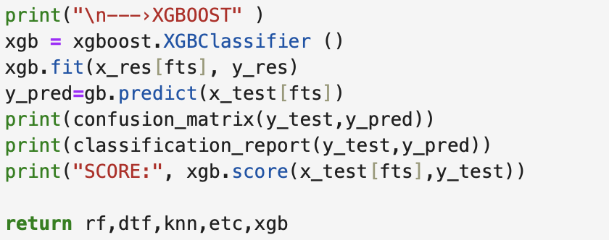

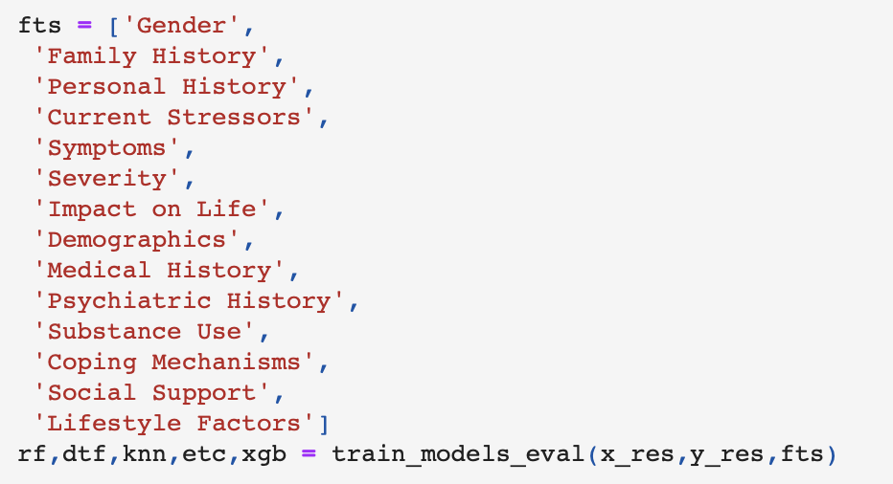

**Model Validation and Evaluation Report:**

|  |  |  |  |
| --- | --- | --- | --- |
| **Model** | **Classification Report** | **Accuracy** | **Confusion Matrix** |
| Random Forest | pasted-movie.png | 92.6% | pasted-movie.png |
| Decision Tree | pasted-movie.png | 92.5% | pasted-movie.png |
| K Nearest Neighbours | pasted-movie.png | 93.7% | pasted-movie.png |
| Extras Tree Classifier | pasted-movie.png | 92.85% | pasted-movie.png |
| XGBoost | pasted-movie.png | 92.47% | pasted-movie.png |